Carbamazepine (without nutrients)
Shapiro-Wilk normality test
data: res
W = 0.9299, p-value = 0.01599
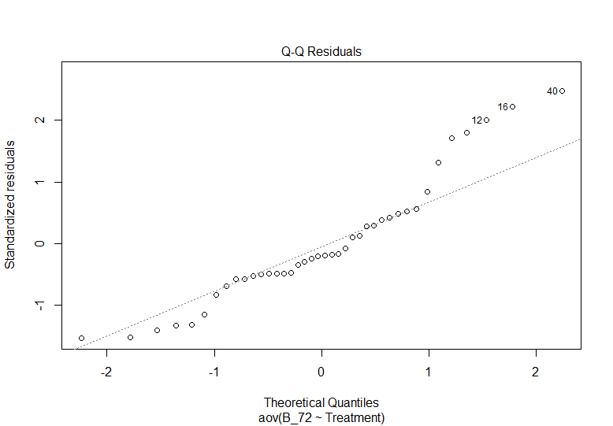
Levene's Test for Homogeneity of Variance (center = median)
Df F value Pr(>F)
group 9 0.9586 0.492
30

Carbamazepine (with nutrients)
Shapiro-Wilk normality test
data: res2
W = 0.99276, p-value = 0.9958
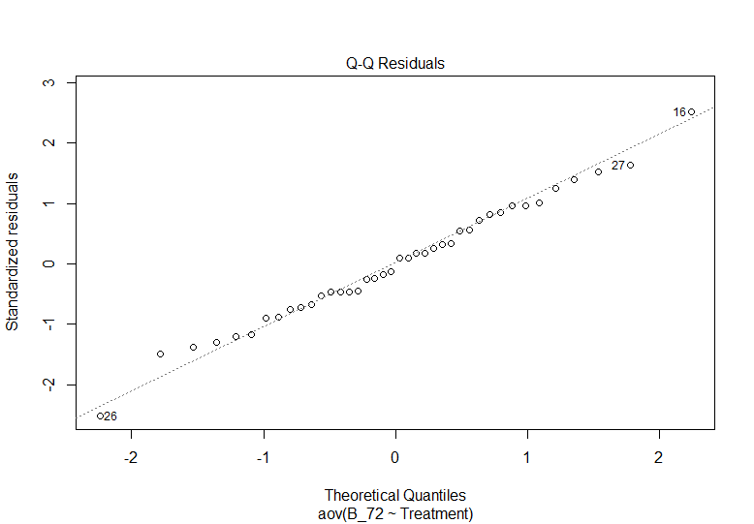
Levene's Test for Homogeneity of Variance (center = median)
Df F value Pr(>F)
group 9 0.3356 0.9558
30

Diclofenac (without nutrients)
Shapiro-Wilk normality test
data: res7
W = 0.9689, p-value = 0.3319
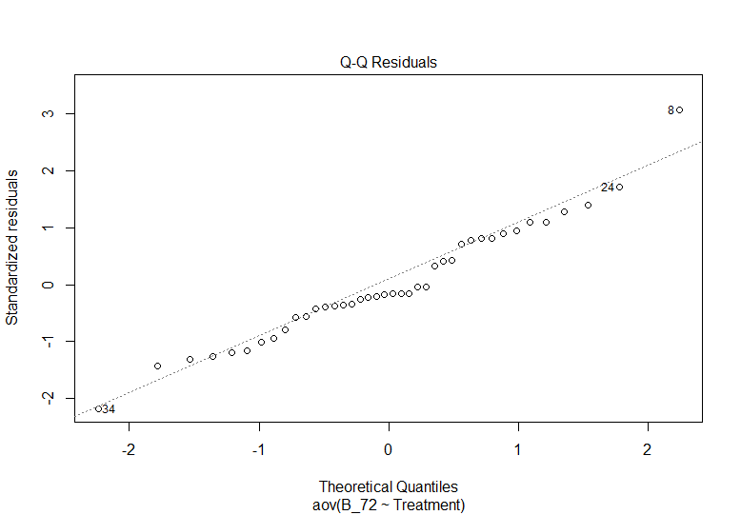
Levene's Test for Homogeneity of Variance (center = median)
Df F value Pr(>F)
group 9 0.6473 0.748
30

Diclofenac (with nutrients)
Shapiro-Wilk normality test
data: res8
W = 0.9852, p-value = 0.8703
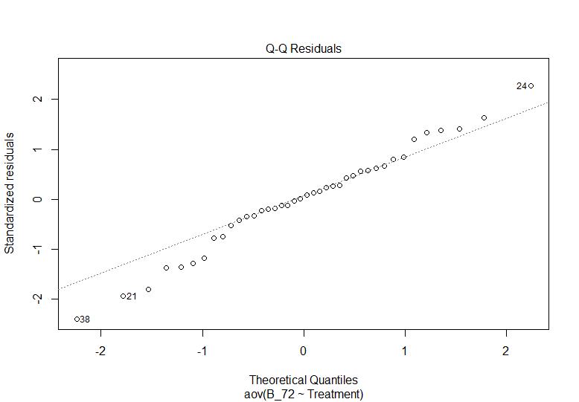
Levene's Test for Homogeneity of Variance (center = median)
Df F value Pr(>F)
group 9 0.6073 0.7808
30

PFOS (without nutrients)
Shapiro-Wilk normality test
data: res3
W = 0.92098, p-value = 0.008266
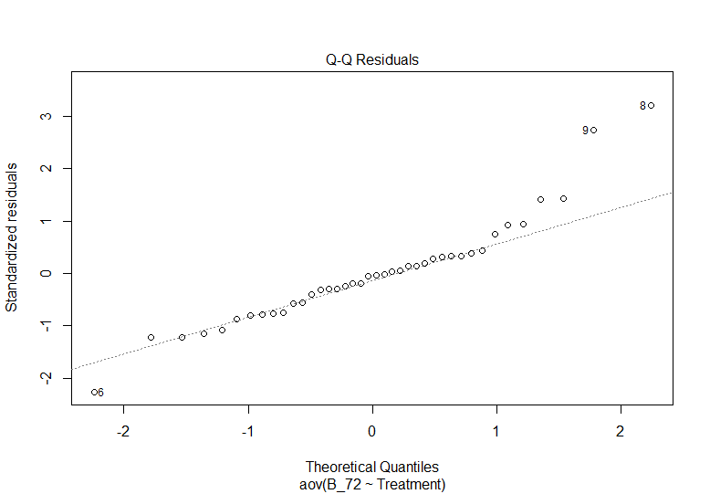
Levene's Test for Homogeneity of Variance (center = median)
Df F value Pr(>F)
group 9 1.0124 0.4523
30

PFOS (with nutrients)
Shapiro-Wilk normality test
data: res4
W = 0.9791, p-value = 0.6561
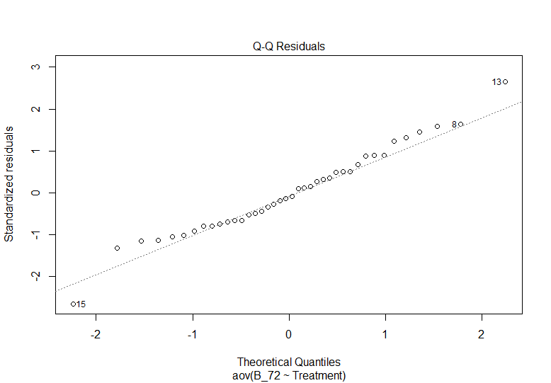
Levene's Test for Homogeneity of Variance (center = median)
Df F value Pr(>F)
group 9 1.0413 0.4318
30

6ppd-q (without nutrients)
Shapiro-Wilk normality test
data: res5
W = 0.95856, p-value = 0.1496
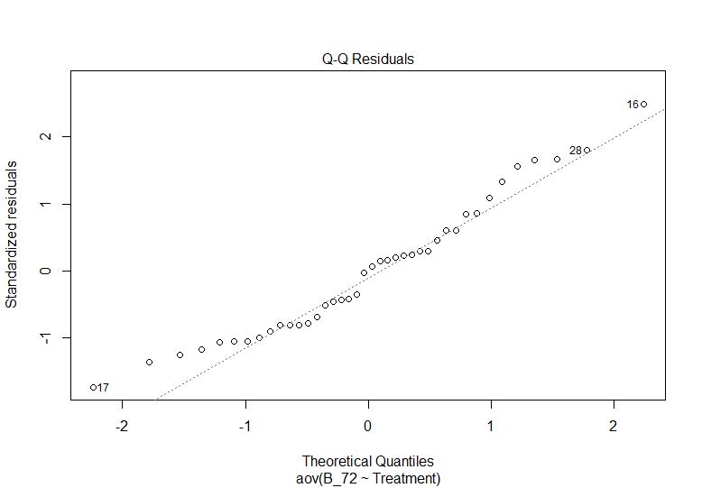
Levene's Test for Homogeneity of Variance (center = median)
Df F value Pr(>F)
group 9 0.834 0.5909
30

6ppd-q (with nutrients)
Shapiro-Wilk normality test
data: res6
W = 0.95083, p-value = 0.08099
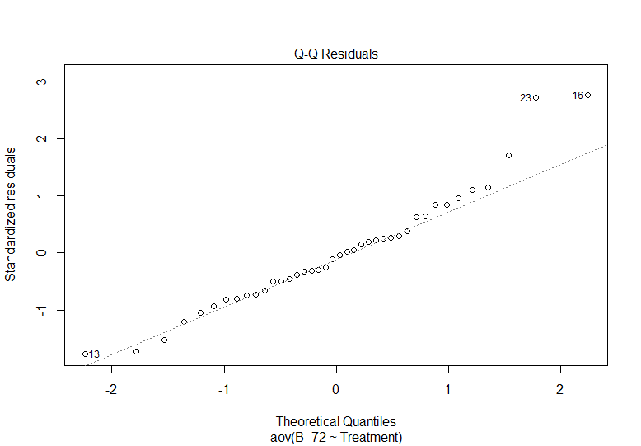
Levene's Test for Homogeneity of Variance (center = median)
Df F value Pr(>F)
group 9 1.3214 0.2675
30

